Project scope document

Restaurant management Application

Project name

Project scope statement

The software will;
- Accurately enter track and delegate customer food and drink orders.
- Monitor and keep track of reservations and availability status in real time.
- Prioritize orders in the kitchen according to arrival of orders and required prep times
- Handle billing and promotional offers
- Track inventory
- Manage employees access
The overall scope of the project is reflected in the use case diagram shown below

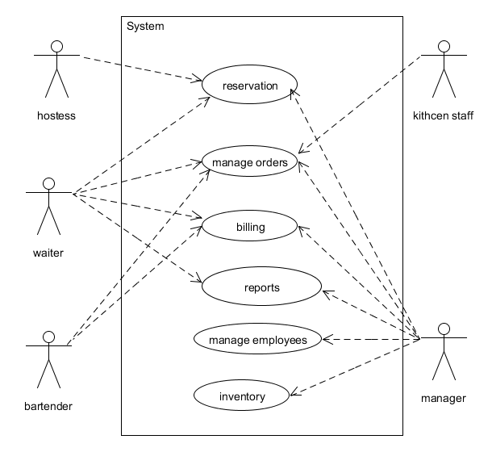
Reservation management include
Adding deleting and confirming reservations
Finding open tables
Assigning open tables
Order management include
Adding, changing, deleting and closing orders
Accessing menu items
Relay customer order to kitchen staff

Billing services will cover
Cash, credit and gift card processing.
Bill splitting
Bill adjustments
Employee management includes
Scheduling, adding and removing employees from database.
Manager should be able to
View aggregated information about sales
View aggregated information about inventory
View aggregated information about employee work
Make adjustments to bill amounts
Inventory management will
Show current stock
Give notice when stock goes below a specific level.

Introduction / Background to project
Restaurants are very busy and if they are inefficiently run can fail even though they are serving great food. Without an application that can keep track of average wait times and the lengths of time spent dinning by customers, it is hard to predict how long the wait time will be for new customers and as we all know customers are very impatient. This application should track and provide the user with data relating to customer wait times, reservation and seating, accounting and auditing, staffing and real time inventory. Leaving the staff to what it should be doing, good food and excellent dining experience

Business case

Wait times will be easily predictable – customer satisfaction.
Seating will be maximized –
Staffing will be maximized depending on predictable patterns

Deliverables

'Deliverables' refers to the outcome or parts of the outcome that lead to the project's successful completion.

Constraints

Constraints refers to any limits, deadlines, delivery dates, etc that will govern the approach you're going to take to complete the project.

Key people / Key stakeholders

Project-team members

Charles Hafslund,
Mikhail Utenkov,
Othman Smihi,
Terry McCarthy,
Fredrick Arandi

Client -

In scope

Describe what the project will cover. In our example, this section might state that the systems and equipment upgrades will cover the customer services team only.

Out of scope

Project administration, monitoring and reporting

Project meetings shall be held every Tuesday in person or via Skype, whichever agreed upon in the previous meeting
Reports and updates shall be logged in github. - Members have to sign documents at each meet

